Test | Hypotheses | Test Statistics
One sample z test about μ  (n ≥ 30) | H₀: μ = μ₀  H₁: µ ≠ (< or >) μ₀ | Z = 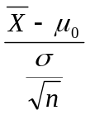 ~ N(0, 1) under H₀
One sample t test about μ  (n < 30) | H₀: μ = μ₀  H₁: µ ≠ (< or >) μ₀ | t = 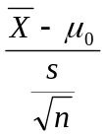 ~ t_{ע} under H₀ where ע = n - 1
Two sample z test about μ₁ – μ₂  (n₁ ≥ 30 and n₂ ≥ 30) | H₀: μ₁ – μ₂ = D  H₁: μ₁ – μ₂ ≠ (< or >) D | Z = 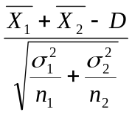 ~ N(0, 1) under H₀
Two sample t test about μ₁ – μ₂ (Independent)  (at least one n_{i} < 30 for i = 1, 2) | H₀: μ₁ – μ₂ = D  H₁: μ₁ – μ₂ ≠ (< or >) D | t = 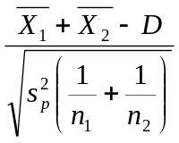 ~ t_{ע} under H₀ where ע = n₁ + n₂ – 2 and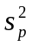 = 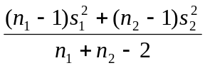
Two sample t test about μ₁ – μ₂ (Dependent)  (n₁ < 30 and n₂ < 30) | H₀: μ₁ – μ₂ = D  H₁: μ₁ – μ₂ ≠ (< or >) D | t = 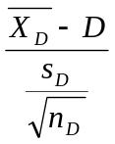~ t_{ע} under H₀ where ע = n_{D} - 1
One-Way ANOVA | H₀: μ₁ = μ₂ = … µ_{k}  H₁: μ_{i} ≠ μ_{j} for some i ≠ j | F = 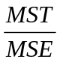~ F_{k-1,n-k} under H₀
One sample z test about p  [np₀ ≥ 5 & n(1 –p₀) ≥ 5] | H₀: p = p₀  H₀: p ≠ (< or >) p₀ | Z = 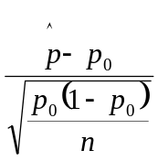N(0, 1) under H₀ where 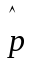= 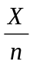
Two sample z test about p₁ – p₂  [n_{i}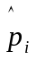≥ 5 & n_{i}(1 -) ≥ 5] for i =1, 2 | H₀: p₁ – p₂ = 0  H₁: p₁ – p₂ ≠ (< or >) 0 | Z = 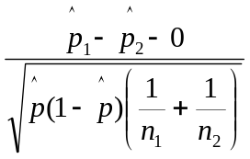 N(0, 1) under H₀ where = 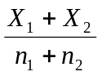, 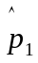 = 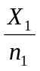, and   